Date Issued: ___________

EXPOSURE NOTICE: Vomiting & Diarrhea

Dear Parent, Legal Guardian, or Staff,

On students and staff may have been exposed to the communicable disease or condition listed below. This notice does not replace medical advice. If your child or a staff member develops symptoms, contact a healthcare provider for diagnosis and treatment to help prevent further spread. For questions, please call your school. If you do not have a healthcare provider or health insurance, call _______________.

VOMITING & DIARRHEA: These symptoms are often caused by bacteria or viruses, most commonly norovirus, which is highly contagious. Other causes include adenoviruses, sapoviruses, and astroviruses. Although sometimes called the “stomach flu,” this illness is not related to influenza.

What are the symptoms? Vomiting, diarrhea, stomachache, poor appetite, weight loss, dehydration, headache, and/or fever.

How is it spread? This illness can spread in several ways: through direct contact with stool from an infected person, or when the virus or bacteria enters the mouth after contact with contaminated hands, food, water, surfaces, or objects. Vomit can also release germs into the air that settle on nearby surfaces. Infection may occur when caring for someone who is sick, sharing toilets, food, or utensils, or cleaning up vomit or diarrhea without protective gear such as gloves, masks, or gowns.

When do symptoms start? 1 to 2 days (24-48 hours) after exposure to the virus or bacteria.

Do staff or children need to stay home if symptoms develop? Yes

The spread of vomiting and diarrhea can be prevented by taking these steps:
- Wash your hands often—before and after eating or preparing food, and after using the toilet. Use soap and water for at least 20 seconds, as hand sanitizers are not effective against many of these viruses.
- Always use diapers with waterproof outer covers that can contain liquid stool or urine, or plastic pants.
- All knives, cutting boards and counters used for raw meat, chicken and fish should be washed thoroughly with hot, soapy water after each use and before using with any other food.
- Never purchase spoiled food. Check dates on labels and store all perishables in refrigerator and serve immediately after preparation.
- Do not allow children to drink from standing water sources such as wading pools.
- Children should wash their hands before and after use of a communal water table and no child should drink from the table.
- Thoroughly clean the soiled surfaces and then disinfect contaminated surfaces immediately after an episode of vomiting or diarrhea by using:
  - Using a mild soap, detergent or cleaning product first to clean
  - Using either a solution of 1 cup of chlorine bleach to 1 gallon of water or an EPA-registered disinfectant to kill nearly all the germs on soiled surfaces
- Machine wash soiled items using detergent and hot water at maximum cycle length and dry at highest heat setting.

CLEANING INSTRUCTIONS
Prevent vomiting and diarrhea with cleaning and disinfection.

Clean

Remove vomit or poop right away.
- Wear protective clothing like gloves, aprons, or masks.
- For carpets or upholstery, use baking soda or other absorbent materials to absorb liquid.
- Do not vacuum. Pick up any mess using paper towels.
- Throw away any food items that may have become contaminated.

Use soapy water to wash surfaces that contacted vomit or diarrhea.
- Clean all nearby high-touch surfaces, like doorknobs and toilet handles.
- Rinse thoroughly with plain water and wipe dry with paper towels.
- Steam cleaning may be necessary for carpets and upholstery.

Machine-wash and dry affected clothes.
- Use hot water, bleach, and detergent. Run on longest setting.

Disinfect

For hard surfaces, prepare a chlorine bleach solution

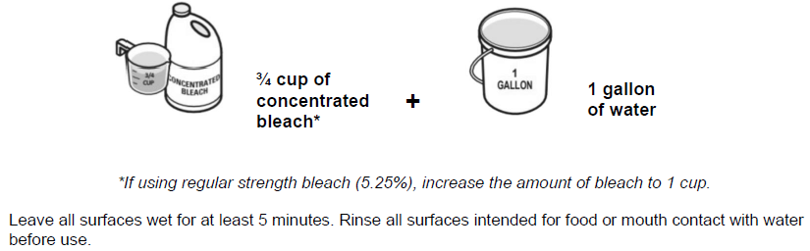

For additional information, visit https://cdc.gov/norovirus/

